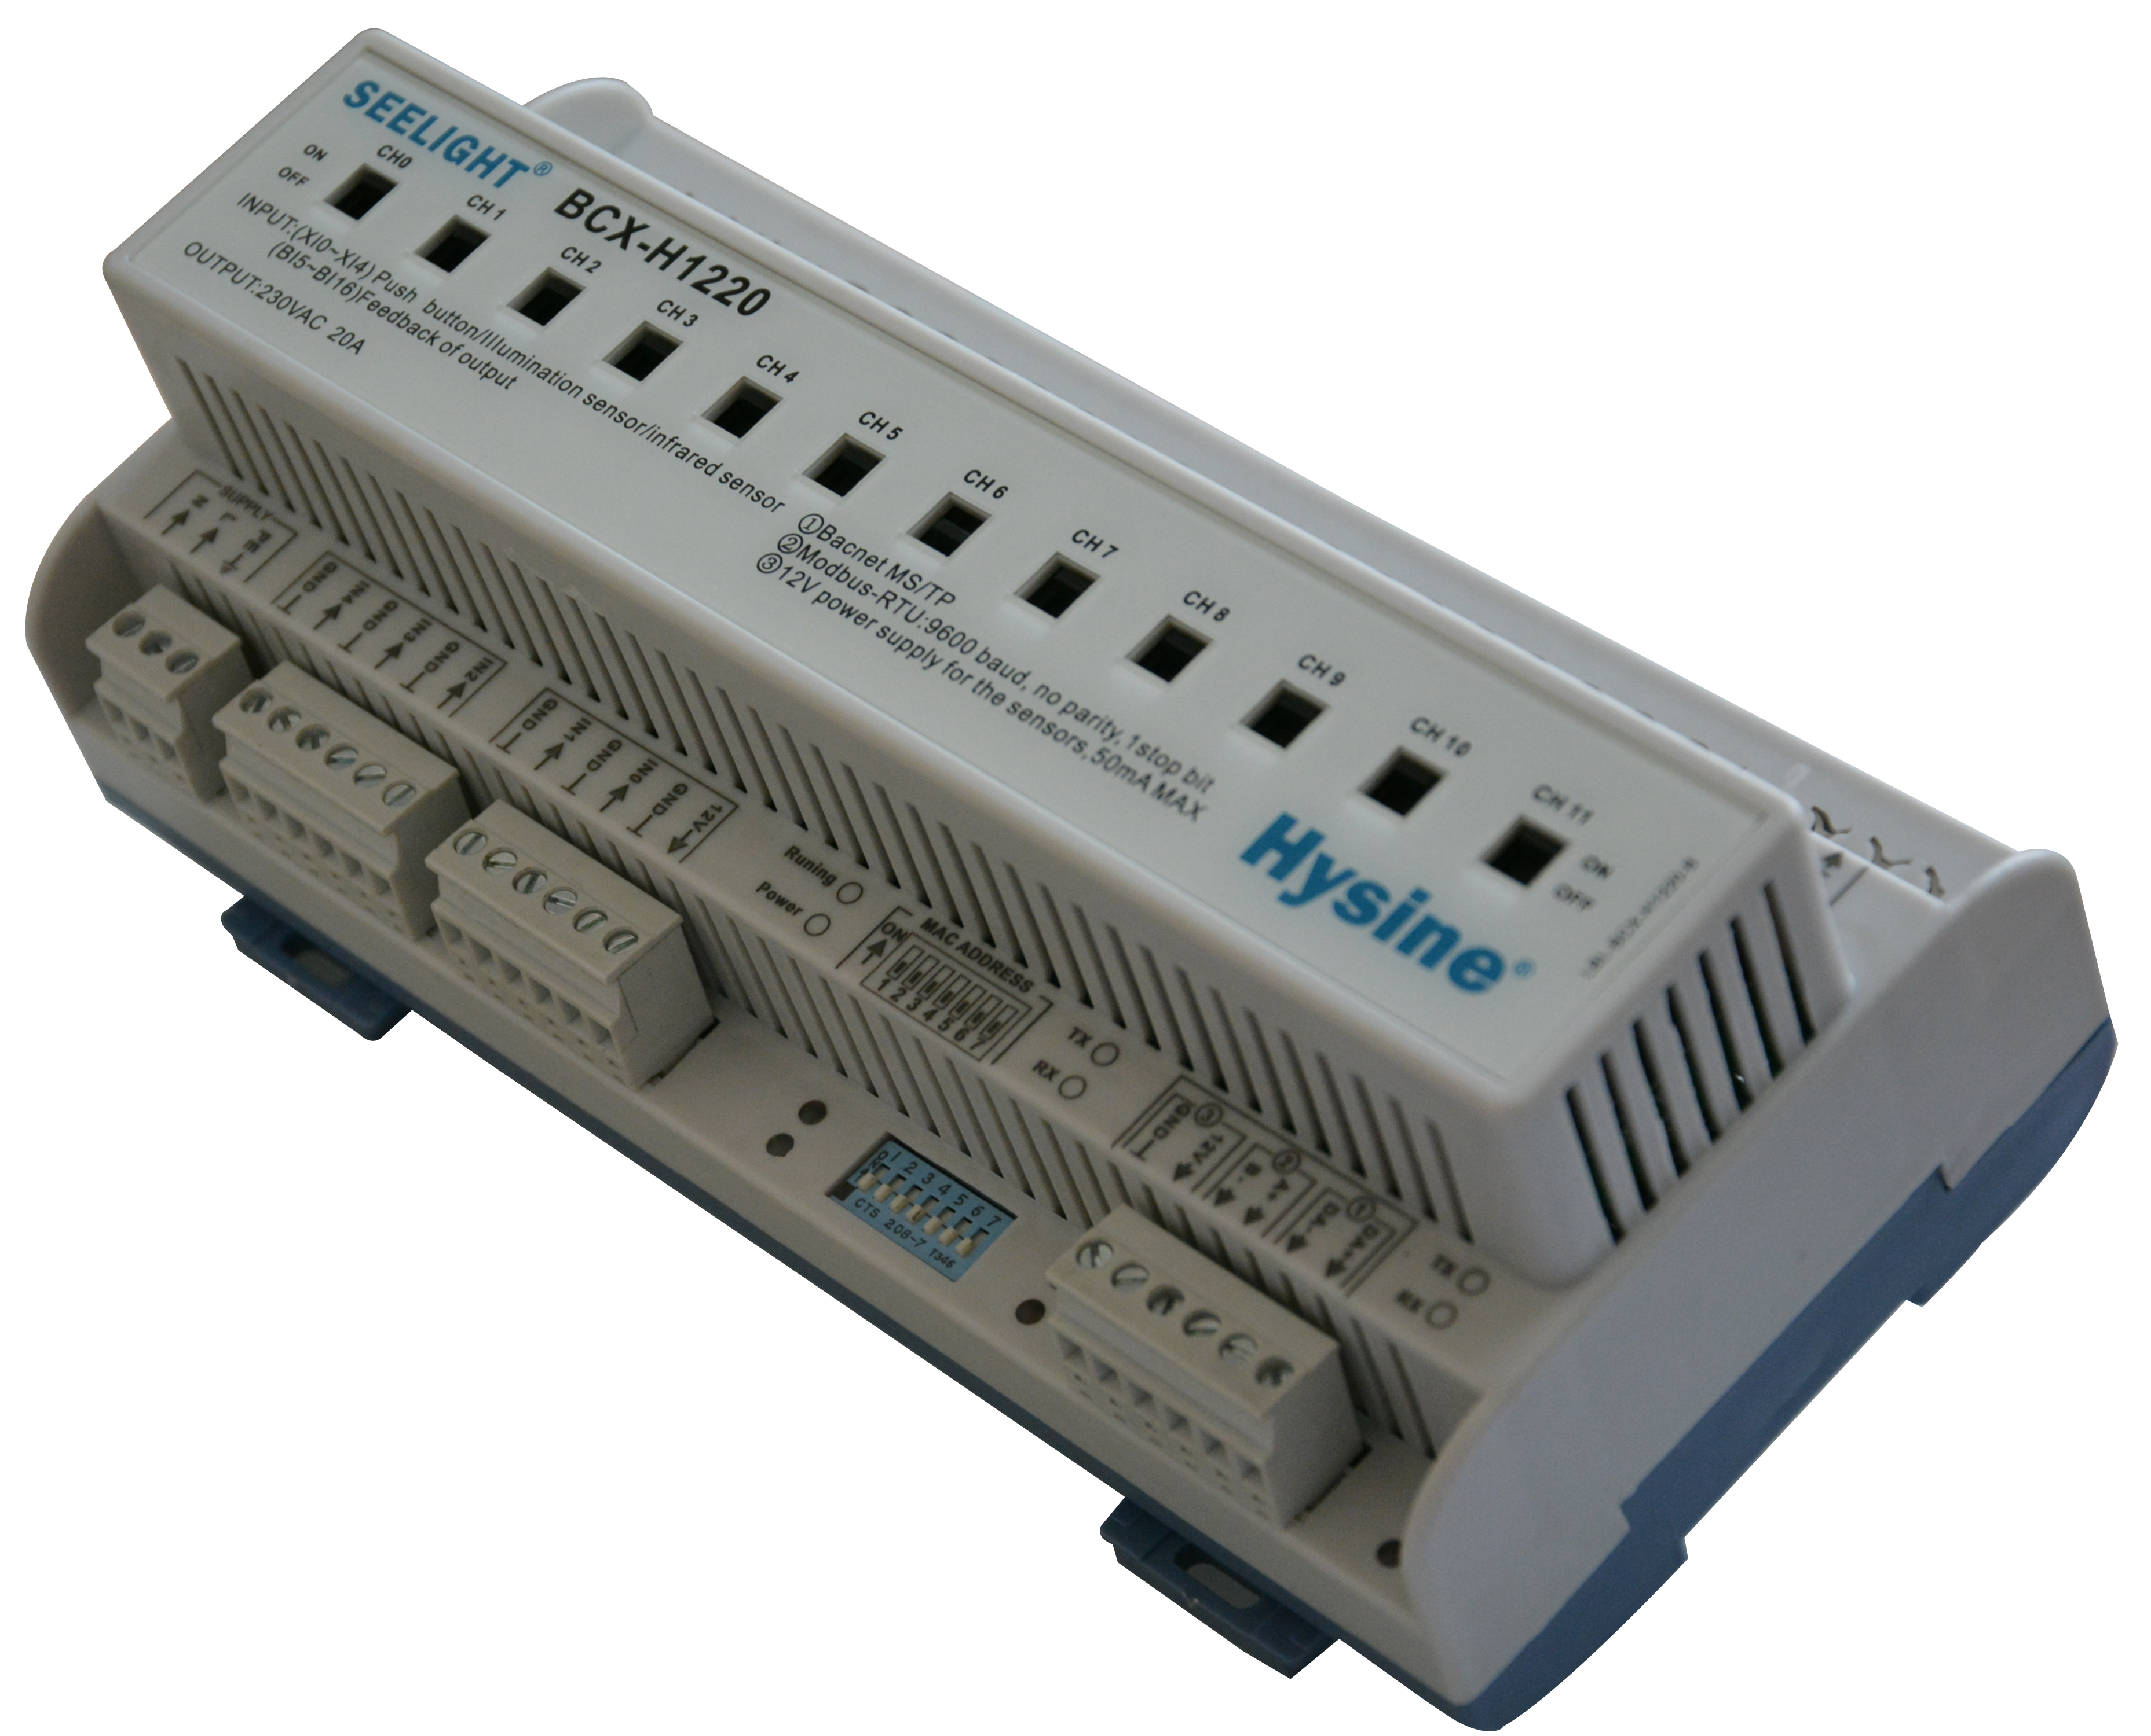
BCX-H1220
The BCX-H1220 is designed to control any type of switched load. The power circuit is of a “feed through” design and is electrically equivalent to a 12 pole contactor, with the additional advantage of each pole being separately controllable via the DyNet network. The BCX-H1220 is DIN rail mountable, designed to be installed in a switchboard next to the circuit breakers feeding the circuits to be controlled
Feature
- Airborne real-time clock with automatic daylight correction and automatic leap year adjustment function.
- Multifunction inlet for connection button, switch, sensor.
- Independent and network capabilities, even if the controller is disconnected from the network, the schedule function can be normal operation
- With dual communication interface, containing BACnet and Modbus protocol.
- Site can easily be manually operated with a manual switch.
Technical data

Control Supply | Output Terminals
230V 50/60Hz single phase & neutral at0.1A | Line In, Line Out for each channel  1 x 4mm2 max conductor size
Control Inputs | Compliance
2*RS485 BACnet、Modbus | CE OR ROHS
User Controls | Operating Environment
Service Switch | 0º to 50ºC ambient temperature  0% to 95% RH non condensing
Internal Controls | Construction
Programmable Logic Controller | ABS DIN rail enclosure
Supply Terminals | Dimensions
Line, Neutral, Earth  1 x 4mm2 max conductor size | 223（W）*104（D）*90(H)
Electrical diagram
CH0 IN
CH0 OUT
CH1 IN
CH2 IN
CH4 IN
CH5 IN
CH1 OUT
CH2 OUT
CH3 OUT
CH4 OUT
CH5 OUT
L
N
L
E
SUPPLY
230V 0.2A
XI0

XI1

XI2

GND

12V

DA+

DA-

A+

B-

CH3 IN
CH6 IN
CH6 OUT
CH7 IN
CH7 OUT
CH8 IN
CH8 OUT
CH9 IN
CH9 OUT
CH10 IN
CH10 OUT
CH11 IN
CH11 OUT

mounting dimensions（MM）

