BR-10
BACnet Router and Global Controller

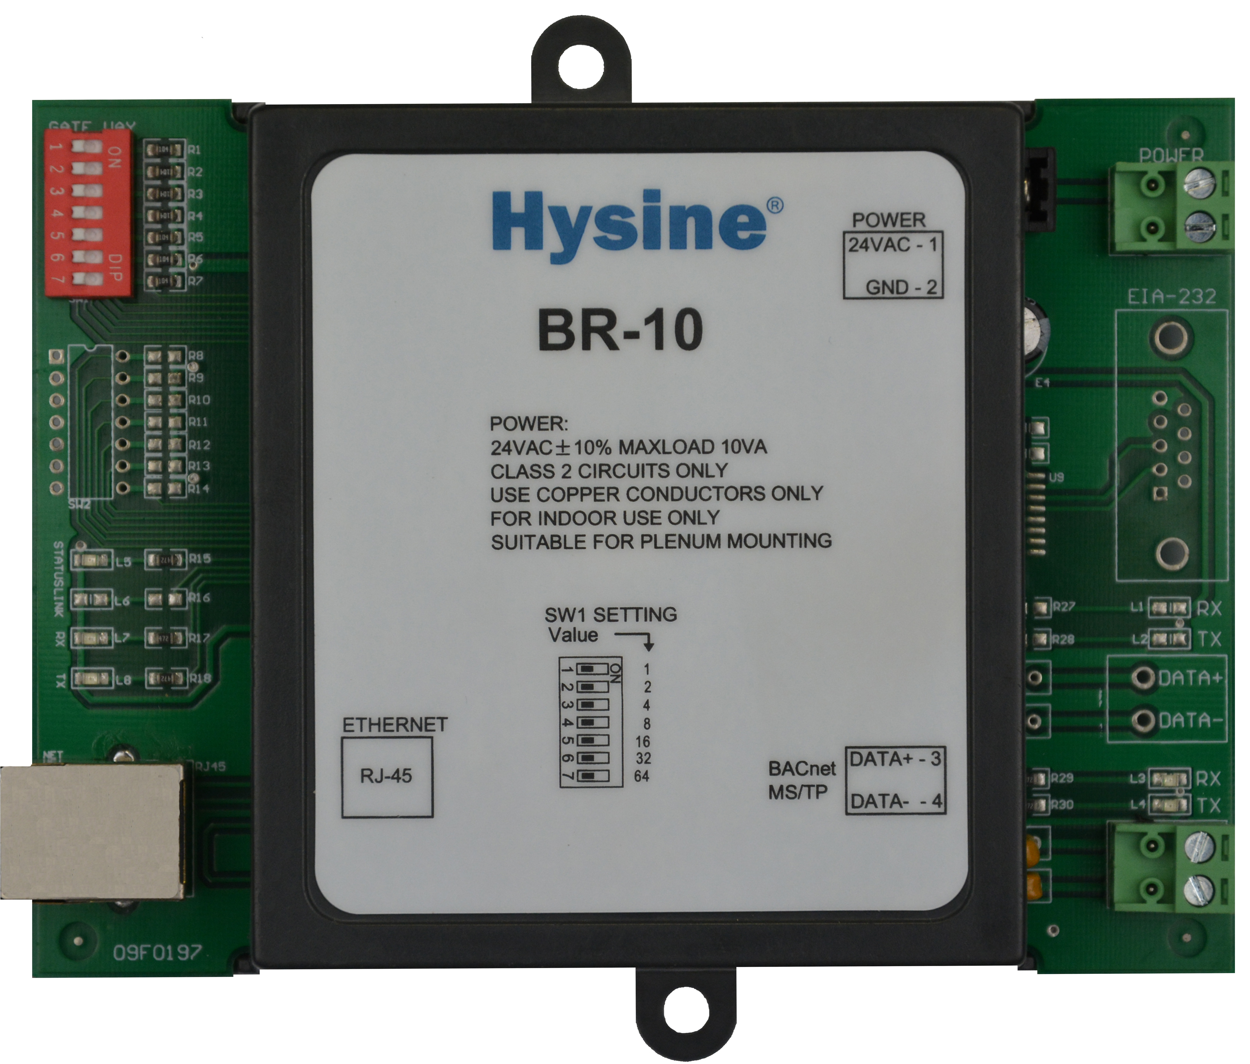
Features and Highlights
- Interoperable
BACnet-compliant controller with 10Base-T Ethernet and One MS/TP connections to BACnet internetwork.
- Versatile
Independent or system-integrated operation. Options for BACnet or BACnet/IP over Ethernet, as well as BACnet PTP over dirent serial cable or optional 9K6 Kbps modem.
- Enterprise ready
Supports BACnet/IP and can operate as BACnet broadcast management device for integration on enterprise and wide area networks.
- Reliable
Extensive onboard filtering, with all program data backed up in nonvolatile flash memory.

Applications and functions
- The BACnet router (BR-10) is the next-generation BACnet-compliant global controller from Hysine. BR-10 can connect to a 10Base-T Ethernet work or operate in a stand-alone capacity. Each BR-10 supports field controllers on one BACnet MS/TP LANs. MS/TP is a simple twisted-pair bus with a configurable speed to 76.8 Kbps. The BR-10 is IP capable for interoperability across campuses or continents.
- The BR-10 independently executes global direct digital control(DDC) algorithms to orchestrate the operation of field controllers o its MS/TP LANs. DDC is programmed at a BACview operator terminal with Hysine’s easy-to-use, Windows-based graphical programming environment , ViewLogic. Revolutionary features like an extensive application library, drag-and-drop DDC edits, dynamic real-time data updates, and self-documentation save time and ease the setup process.
- The BR-10 can access available data as BACnet objects and properties from throughout BACnet internetwork, making its operational status and contrl data available to other BACnet devices in the same way. This enables an unmatched level of interoperability with other site systems.
- For sites that raguire independent operation with remote access, a BR-10 with an optional 9.6 Kbps modem is available for alarm dealout and remote access. A9-pin RS-232 port on all BR-10 supports BACnet PTP connections, including roaming BACview operator terminal connections.
- CMOS circuitry,a four layer circuit board with separate ground plane, and extensive hardware software,and power-supply filtering ensure reliable and stable operatio. The CMOS processor uses an internal watchdog,and power supply voltage is monitored to provide automatic shutdown and data backup.

Ordering information
Item number Description .
BR-10 10Base-T to BACnet Ethernet and one BACnet MS/TP network

Technical Data
- Power 24 VADC @ 10VA. Utilizes a half-wave rectifier, which allows a single transformer to power Multiple BRs. One leg of 24VAC connects to earth (panel) ground.
- Battery Replaceable 3.0V lithium battery provides up to 1.5 years(cumulative) real-time clock(without external power supply). Standby battery life is 10 years. Coin-cell type BR1225 or equivalent.
- Processor & memory AVR processor with onboard flash memory and RAM.
- BACnet Ethernet Integrated Ethernet adapter circuitry with RJ-45 jack for connection to 10Base-T(10 Mbps) or 100Base-TX(100 Mbps) networks.
- BACnet IP IP support for interoperability on wide area networks(WANs) and campus area networks(CANs). Functions as a BACnet Broadcast Management Device in accordance with “Annex J” BACnet/IP.
- BACnet MS/TP Removable, header-style screw terminal for 1 BACnet MS/TP(shielded twisted-pair bus)LANs,each individually configurable from76.8 Kbps.
- Dimensions (112mm)H × (140mm)W × (38mm)D
- Environmental 0-55℃.0-95%RH,non-condensing.
- Communications BACnet MS/TP LAN up to 76.8Kbps.
- BACnet conformance An application specific controller (ASC).
- Ratings EMC GB/T 17626

Dimension[mm]

